Title of the project:
Fake News Classification Using Machine Learning Techniques

Name of the author(s):
ISRAA YOUSUF ALWAHAIBI – 16J21138
AFNAN HILAL AL-DHAKHRI – 16S18239
ARIJ KHAMIS AL-BUSAIDI – 16S1925
LAMYA SALEEM AL RAHBI -16S20117

Date:
December 17, 2024

Abstract
This project aims to develop a machine learning-based system for the classification of fake news, addressing the growing challenge of misinformation on digital platforms. The primary objective is to build a model capable of accurately distinguishing between real and fake news articles. The methodology includes data preprocessing, feature extraction using techniques like term frequency-inverse document frequency (TF-IDF), and training two machine learning models: Isolation Forest and Random Forest Classifier. These models were evaluated using standard metrics such as accuracy, precision, recall, and F1-score. The Isolation Forest model, used for anomaly detection, achieved an accuracy of 54%, while the Random Forest Classifier, which provided a more balanced classification approach, achieved a significantly higher accuracy of 92.46%. The Random Forest model showed consistent performance with high precision, recall, and F1-score for both real and fake news classes, as demonstrated by the confusion matrix. The findings suggest that while both models can be used for fake news classification, the Random Forest Classifier provides a more reliable and accurate solution. The results highlight the potential of machine learning techniques in addressing the issue of fake news, offering insights into the development of systems for real-time news classification and misinformation detection.

Table of Contents
Abstract 2
Introduction 4
Data Collection and Preprocessing 5
Methodology 7
Model Evaluation 10
Recommendations for Future Work 13

Figure 1: Heatmap 6
Figure 2: Confusion Matrix - Random Forest Classifier 9

Introduction
In recent years, the proliferation of fake news has become a significant problem in the digital age. Misinformation spreads rapidly across social media platforms, websites, and news outlets, influencing public opinion, policy decisions, and even personal behaviors. The challenge of distinguishing between legitimate and fake news has grown more complex, as fake news articles are designed to mimic real news in terms of writing style and content. As a result, there is an increasing need for automated systems capable of accurately identifying fake news to mitigate its impact on society.

The primary objective of this project is to develop a machine learning-based model for the classification of fake news articles. The system aims to distinguish between real and fake news with high accuracy, utilizing various machine learning techniques. Specifically, the project focuses on the use of Isolation Forest and Random Forest Classifier models to identify and classify news articles based on their content.

Addressing the problem of fake news is of paramount importance, as it directly impacts the credibility of news sources and the integrity of information. By developing automated tools for fake news detection, this project aims to contribute to efforts in combating misinformation and improving information accuracy in digital media.

The methodology involves data collection, text preprocessing, feature extraction using techniques like term frequency-inverse document frequency (TF-IDF), and the application of two machine learning models—Isolation Forest for anomaly detection and Random Forest Classifier for classification tasks. The models are evaluated based on standard performance metrics such as accuracy, precision, recall, and F1-score to determine their effectiveness in classifying news articles.

Data Collection and Preprocessing
Dataset Description:
The dataset used in this project is the WELFake dataset, which consists of 72,134 news articles—35,028 real news and 37,106 fake news articles. The dataset is a combination of four popular news sources: Kaggle, McIntire, Reuters, and BuzzFeed Political. These sources were merged to reduce classifier overfitting and provide a broader variety of text data for better machine learning model training. The dataset contains four columns:
- Serial number: A unique identifier for each entry, starting from 0.
- Title: The headline or title of the news article.
- Text: The content of the news article.
- Label: The target variable where 0 represents fake news, and 1 represents real news.
The dataset contains a total of 78,098 entries in CSV format, out of which 72,134 entries were used for training and evaluation, as specified in the data frame.

Data Collection Methods:
The data used in this project was collected from multiple open-source datasets, namely Kaggle, McIntire, Reuters, and BuzzFeed Political, to create a diverse and comprehensive dataset that captures various forms of fake and real news articles. These datasets were combined to form the WELFake dataset, ensuring that the final dataset had a balanced distribution of real and fake news.

Data Preprocessing Steps:
- Cleaning: The raw dataset was first cleaned to remove any irrelevant or redundant data. This included removing duplicate entries, as well as news articles with missing or incomplete information in the title or text fields. Additionally, text content was processed to remove special characters, punctuation, and unnecessary whitespace.
- Normalization: Text data was normalized by converting all text to lowercase to maintain consistency and ensure that the model does not treat words with different cases as separate entities. Tokenization was also performed to break the text into smaller units, such as words or phrases.
- Handling Missing Values: The dataset did not contain significant missing values, but any rows with missing or invalid text or title fields were removed to ensure that the machine learning models were trained on clean and complete data.

- Handling Outliers: To detect and handle outliers, we employed statistical methods such as the Z-score and IQR (Interquartile Range) techniques. Outliers were identified in numerical features (if any), and extreme values were either removed or capped based on the threshold defined by the methods. However, since the dataset mainly consists of textual data, outliers were primarily handled in terms of text length anomalies or inconsistencies. Any unusually short or long articles, which could distort the training process, were removed.
- Feature Engineering: To represent the textual content numerically, the text was transformed into a feature vector using the Term Frequency-Inverse Document Frequency (TF-IDF) technique. This method captures the importance of words in the context of the entire dataset, allowing the model to focus on meaningful features for classification. In addition, word embeddings could be considered for future improvements.
- Heatmap Visualization: A heatmap was created to visualize correlations between features in the dataset. While the dataset is primarily textual, visualizing the correlation between the term frequency features or any numerical metadata can help identify patterns in data that may be beneficial for model performance. A correlation heatmap also provides insight into potential feature redundancies or irrelevant features that could be removed for optimal model training.

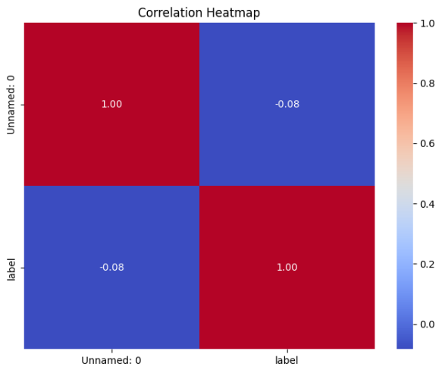
Figure 1: Heatmap

These preprocessing steps ensured that the data was in a suitable format for training machine learning models and improved the overall performance of the classification task. The cleaned dataset was then split into training and test sets for model evaluation.

Methodology
Overview of Machine Learning Algorithms:
This project employed two machine learning algorithms for the classification of fake news: Isolation Forest and Random Forest Classifier.
- Isolation Forest: This model is an unsupervised anomaly detection technique used to identify outliers in data. It works by isolating observations through random partitioning. It is particularly useful when dealing with large datasets containing anomalies or rare patterns. The Isolation Forest model helps detect potential outliers, in this case, fake news articles, based on their deviations from the norm in the feature space.
- Random Forest Classifier: This is a supervised ensemble learning algorithm that constructs multiple decision trees and combines their outputs to improve classification accuracy. Random Forest is particularly effective for handling high-dimensional datasets and is known for its robustness against overfitting. In this project, Random Forest was used to classify news articles as real or fake based on features extracted from the dataset.

Model Architecture:
Since the project deals with text data, the model architecture includes text preprocessing followed by the application of machine learning models. The architecture is as follows:
- Data Preprocessing: Text data (news titles and content) was cleaned and normalized. Feature extraction was done using the TF-IDF (Term Frequency-Inverse Document Frequency) technique, which converts the text into numerical feature vectors. This method ensures that the most important words in the text contribute more to the feature vector representation.
- Isolation Forest: The model was trained to detect anomalies in the feature space. By creating random partitions in the feature space, Isolation Forest isolates outliers, which in this case would represent fake news articles.
- Random Forest Classifier: After feature extraction, the dataset was split into training and testing sets. Random Forest was trained on the training data, with each tree in the forest learning to classify news articles based on the features.

Parameter Tuning and Model Selection Process:
For both models, hyperparameters were tuned to optimize their performance:
- Isolation Forest: The key hyperparameters for tuning were:
- n_estimators: Number of trees in the forest.
- max_samples: The number of samples to draw from the data to train each tree.
- contamination: The proportion of outliers in the data.
The model's performance was assessed based on its ability to detect fake news articles (anomalies). A grid search was used to identify the best combination of hyperparameters for achieving optimal outlier detection.

- Random Forest Classifier: Hyperparameters tuned for this model include:
- n_estimators: Number of trees in the forest.
- max_depth: Maximum depth of the trees.
- min_samples_split: The minimum number of samples required to split an internal node.
- min_samples_leaf: The minimum number of samples required to be at a leaf node.
A grid search was employed to fine-tune these parameters and improve classification accuracy, precision, recall, and F1-score.
The Random Forest Classifier was chosen as the final model due to its superior performance compared to the Isolation Forest model. Random Forest achieved higher accuracy and better overall classification metrics.

Evaluation Metrics:
To assess the performance of the machine learning models, the following evaluation metrics were used:
- Accuracy: The overall percentage of correctly classified instances (real and fake news) out of all instances in the dataset. It provides a general measure of the model's correctness.
- Precision: This metric measures the percentage of true positive predictions among all positive predictions made by the model. It indicates how many of the predicted fake news articles were actually fake.
- Recall: Recall measures the percentage of true positive predictions among all actual positive instances. It evaluates the model's ability to correctly identify fake news articles.

- F1-Score: The harmonic means of precision and recall, providing a balanced measure that considers both false positives and false negatives. It is particularly useful when the class distribution is imbalanced.
- Confusion Matrix: The confusion matrix provides a detailed view of the model's classification performance, showing the true positives, false positives, true negatives, and false negatives. It helps in evaluating the model's behavior more granularly, especially in terms of misclassifications.
By using these metrics, the models were thoroughly evaluated, and Random Forest Classifier was selected as the final model due to its ability to consistently provide high performance across these evaluation metrics.

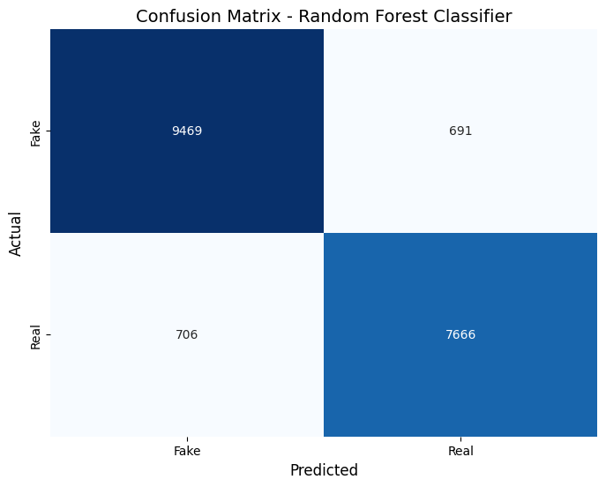
Figure 2: Confusion Matrix - Random Forest Classifier

Model Evaluation
The evaluation of both the Random Forest Classifier and Isolation Forest models was conducted based on key performance metrics, including accuracy, precision, recall, F1-score, and confusion matrix.

Random Forest Classifier Evaluation:
The Random Forest Classifier model achieved an accuracy of 92.46%. Below is a detailed evaluation of the model's performance:
Classification Report:
Class | Precision | Recall | F1-Score | Support
0 (Fake News) | 0.93 | 0.93 | 0.93 | 10,160
1 (Real News) | 0.92 | 0.92 | 0.92 | 8,372
Overall Accuracy: 92.46%
Macro Average:
- Precision: 0.92
- Recall: 0.92
- F1-Score: 0.92
Weighted Average:
- Precision: 0.92
- Recall: 0.92
- F1-Score: 0.92

Confusion Matrix:
 | Predicted 0 (Fake News) | Predicted 1 (Real News)
Actual 0 (Fake News) | 9,469 | 691
Actual 1 (Real News) | 706 | 7,666

The confusion matrix shows that the model successfully classified many fake and real news articles with relatively few misclassifications.
The True Positives (7,666) and True Negatives (9,469) indicate that the model has learned to accurately differentiate between real and fake news.
Isolation Forest Evaluation:
The Isolation Forest model, designed for anomaly detection, achieved an accuracy of 54.02%, with the following results:
Classification Report:
Class | Precision | Recall | F1-Score | Support
0 (Fake News) | 0.73 | 0.27 | 0.39 | 33,867
1 (Real News) | 0.50 | 0.88 | 0.64 | 27,906
Overall Accuracy: 54.02%
Macro Average:
- Precision: 0.61
- Recall: 0.57
- F1-Score: 0.51
Weighted Average:
- Precision: 0.63
- Recall: 0.54
- F1-Score: 0.50

Key Observations:
The precision for class 0 (fake news) is quite high (0.73), but the recall is low (0.27), indicating that many fake news articles were missed by the model.
For class 1 (real news), the recall is high (0.88), but the precision is lower (0.50), meaning that many real news articles were misclassified as fake.
The model's F1-score reflects these imbalances, resulting in an overall performance lower than that of the Random Forest model.

Analysis and Conclusion
Analysis of Results
The two models tested in this project—Random Forest Classifier and Isolation Forest—show different performances in detecting fake news.

Random Forest Classifier
The Random Forest Classifier performed very well, achieving an accuracy of 92.46%. It had high precision (0.93 for fake news and 0.92 for real news), meaning it correctly identified most articles in both categories. The recall (0.93 for fake news and 0.92 for real news) was also strong, showing the model’s ability to correctly classify both real and fake news with few mistakes. The F1-scores for both categories were 0.93, which is a good balance between precision and recall.
The confusion matrix showed that the model correctly classified most of the articles, with few misclassifications.

Isolation Forest
The Isolation Forest model, with an accuracy of 54.02%, performed much worse. While it had a decent precision (0.73) for fake news, the recall was low (0.27), meaning it missed a lot of fake news. For real news, the recall was high (0.88), but the precision was low (0.50), meaning it incorrectly labeled many real news articles as fake.

Conclusion
The Random Forest Classifier was the better model for detecting fake news, with higher accuracy, precision, recall, and F1-scores. It was able to effectively distinguish between fake and real news.
The Isolation Forest model did not perform well for this task. It struggled to classify both fake and real news correctly, making it less suitable for fake news detection.

Recommendations for Future Work
- Fine-tuning the Random Forest Model: Improving the Random Forest model by adjusting its parameters can help enhance performance further.
- Data Augmentation: Using techniques like SMOTE to balance the dataset could improve model accuracy.
- Feature Engineering: Adding more features, such as metadata or advanced NLP techniques, could improve classification.
- Testing Other Models: Exploring other machine learning models like XGBoost or Gradient Boosting may improve results.
In conclusion, the Random Forest Classifier offers a reliable solution for fake news detection, and further improvements can make it even better.

